**Industrial Training Report**

**On**

**Pashchimanchal Vidyut Vitran Nigam Limited**

Conducted At: 132/33 KV Substation Chandpur, Bijnor



Under supervision of:

**Er. Ankur Kumar**

**Executive Engineer**

**Pashchimanchal Vidyut Vitran Nigam Limited**

**Chandpur, Bijnor**

Submitted By:

**SHIVAM**

**Roll No.: 2107350200044**

**Session: 2024 – 2025**



**Submitted To:**

**Dr. Archana Sharma & Dr. Mohmmad Ahmad**

**(Assistant Professor, Department of Electrical Engineering)**

**Rajkiya Engineering College, Bijnor, Uttar Pradesh 246725**

**Affiliated to Dr. A P J Abdul Kalam Technical University, Lucknow, U. P.**

**DECLARATION**

# I hereby declare that the industrial training report on Pashchimanchal Vidyut Vitaran Nigam

# Ltd, conducted at 132/33 KV Substation Chandpur, Bijnor is an authentic record of my own work as requirement of industrial training during the period from 15-07-2024 to 25-08-2024 for the award of degree of Bachelor of Technology (Electrical Engineering), Rajkiya Engineering College Bijnor under the guidance of Dr. Archana Sharma and Dr. Mohmmad Ahmad.

**SHIVAM**

2107350200044

Date: ……………………

Certified that the above statement made by the student is correct to the best of our knowledge and belief.

**SIGNATURE**

Examined By:

**TRAINING CERTIFICATE**

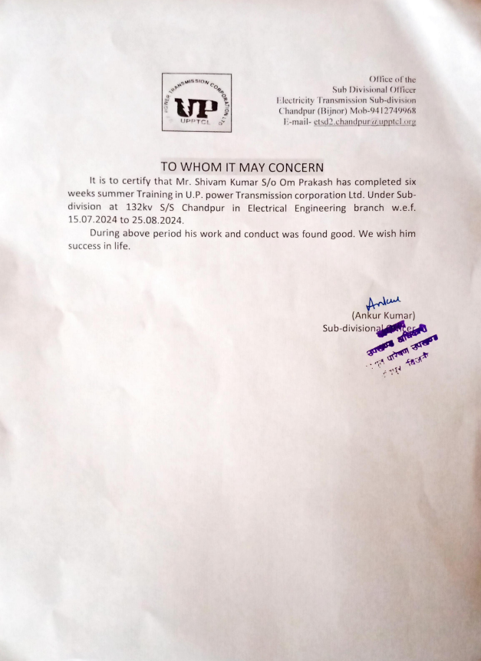

# TABLE OF CONTENTS

**ACKNOWLEDGEMENT**  i

**LIST OF FIGURES** ii

1. **Introduction 1-2** 
   1. About 132/33 KV substationChandpur, Bijnor
   2. Single Line Diagram

**2. Transformers 3-5**

2.1 Types of Transformers 3-5

2.1.1 Power transformer 4 2.1.2 Instrument transformer 4 2.1.3 Autotransformer 4 2.1.4 On the basis of working 5 2.1.5 On the basis of structure 5

**3. Specification of C.T. used in 132/33 KV s/s Chandpur 6**

**4. Substation 7 -12**

4.1 Types of substation 8

4.1.1 According to the service requirement 8 4.1.2 According to the constructional features 8

4.2 Substation characteristics 9

4.3 Steps in designing substation 10

4.3.1 Earthing and bonding 10

4.3.2 Substation earthing calculation methodology 11 4.3.3 Earthing material 11 4.3.4 Switch yard fence earthing 11

4.4 Conductors used in substation designing 12

**5. Chronological training diary 13-16**  5.1 Power line carrier communication(PLCC) 13

5.1.1 Applications 13

5.2 Principle of PLCC 14

5.2.1 Wave trap or line trap 14 5.2.2 Coupling capacitor 14 5.2.3 Protective device of coarse voltage arrester 15 5.2.4 Coupling of filter 15 5.2.5 H.F. cable 16

## 6. Bus bars 17-18

## 7. Insulators 19-23

7.1 Circuit breakers 20 7.2 Oil circuit breaker 21 7.3 Air blast circuit breaker 21 7.4 Sulphur hexafluoride circuit breaker (SF6)circuit breaker 22 7.5 Vacuum circuit breaker 23

## 8. Metering and Indication equipment 25-28

8.1 Relay 25 8.2 Relays used in control panel of substation 26

8.2.1 Differential relay 26 8.2.2 Over current relay 26 8.2.3 Directional relay 27 8.2.4 Tripping relay 27 8.2.5 Auxiliary relay 28

1. **Miscellaneous Equipment’s 29-27** 9.1Capacitor bank 29 9.2 Fuse 30 9.3 Bus coupler 30
2. **Lighting arrester 31**
3. **Protection of substation 32** 11.1Transformer protection 32 11.2 Conservation and breather 32 11.3 Marshalling box 32 11.4 Transformer cooling 32
4. **Conclusion 33**

**References 34**

# ACKNOWLEDGEMENT

# Training has an important role in exposing the real life situation in an industry. It was a great experience for me to work on training at Pashchimanchal Vidyut Vitaran Nigam Ltd.

Through which I could learn how to work in a professional environment. Now, I would like to thank the people who guided me and have been a constant source of inspiration throughout the tenure of my summer training. I am sincerely grateful to **Er.** **Ankur Kumar (Sub Divisional Officer) at 33/11 KV substation Chandpur, Bijnor** who rendered me his valuable assistance, constant encouragement and able guidance which made this training actually possible. I wish my deep sense of gratitude to **Er. Yogesh Kumar (Assistant Engineer)** whose affectionate guidance has enabled me to complete this training successfully. I also wish my deep sense of gratitude to **Dr. Archana Sharma** and training guide **Dr. Mohmmad Ahmad** and other faculty memberswhose guidance and encouragement made my training successful.

**SHIVAM**

# 

**LIST OF FIGURES**

**Figure no.** **Name of figure** **Page no.**

|  |  |
| --- | --- |
| Figure 1.1  Figure 1.2 | 132/33 KV Substation 1  Single Line Diagram 2 |
| Figure 2.1 | Transformer 3 |
| Figure 2.2 | Power transformer 4 |
| Figure 2.3 | Instrument transformer 4 |
| Figure 2.4 | Auto transformer 5 |
| Figure 2.5 | Core type 5 |
| Figure 2.6 | Shell type 5 |
| Figure 3.1 | Current transformer 6 |
| Figure 4.1 | View of substation 7 |
| Figure 4.2 | Transformer substation 8 |
| Figure 5.1 | Power Line Carrier Communication(PLCC) 13 |
| Figure 6.1 | Typical representation of bus bars 17 |
| Figure 7.1 | Insulators used in substation 19 |
| Figure 7.2 | Circuit breaker arrangements 20 |
| Figure 7.3 | Oil circuit breaker 21 |
| Figure 7.4 | Air blast circuit breaker 22 |
| Figure 7.5 | SF6 Circuit breaker 22 |
| Figure 7.6 | Vacuum circuit breaker 23 |
| Figure 8.1 | Typical view of Relay 25 |
| Figure 8.2 | Differential Relay 26 |
| Figure 8.3 | Over current Relay 26 |
| Figure 8.4 | Directional Relay 27 |
| Figure 8.5 | Tripping Relay 27 |
| Figure 8.6 | Auxiliary Relay 28 |
| Figure 9.1 | Capacitor bank 29 |
| Figure 9.2 | Substation fuse 30 |
| Figure 9.3  Figure10.1 | Bus coupler 30  Lightning arrestor 31 |

**INTRODUCTION**

Pashchimanchal Vidyut Vitran Nigam Ltd. is a company incorporated under the Companies Act, 1956 and having its registered office at Chandpur, Bijnor for carrying out the business of Distribution of electricity within the Area of Supply. Area of supply will include the following area: Peepalsana, Ladhupura, Tehsil Chandpur, Mahindra, Chandpur bank, Kakrala, Bagarpur, Basta, Chandpur, Siau, Sisona, Masit.

## 1.1 ABOUT 132/33 KV SUBSTATION CHANDPUR

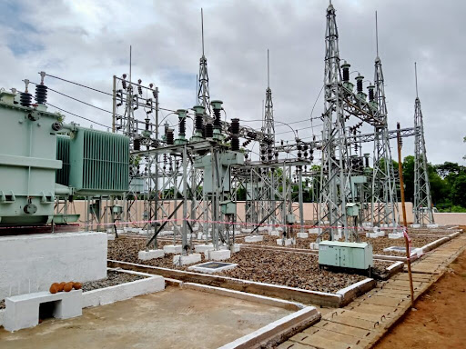

### Figure 1.1 132/33KV Substation Chandpur

The substation 132/33 KV Chandpur have three incoming lines

1. 132 KV Nehtaur
2. 33 KV Chandpur

Now the transmission line first parallel connected with lightning arrester to diverge surge, followed by CVT (continuous variable transmission) connected parallel. At the location a wave trap is connected to carrier communication at higher frequencies. A current transformer is connected in series with line which measure current and step down for control panel.

Switchgear equipment is provided, which is the combination of a circuit breaker having an isolator at each end. A transformer is connected to main bus though a bus coupler. At both ends of transformer lightning arrester current transformer and switchgear equipment.

**1.2 SINGLE LINE DIAGRAM (SLD)**

A Single Line Diagram (SLD) of an Electrical System is the Line Diagram of the concerned Electrical System which includes all the required ELECTRICAL EQUIPMENT connection. sequence wise from the point of entrance of Power up to the end of the scope of the mentioned Work.

As these feeders enter the station they are to pass through various instruments. The instruments have their usual functioning.

**They are as follows in the single line diagram:**

* Lightening arrestors
* CVT
* Wave trap
* Isolators with earth switch
* Circuit breaker
* BUS
* Potential transformer with a bus isolator
* Isolator
* Current transformer
* A capacitor bank attached to the bus

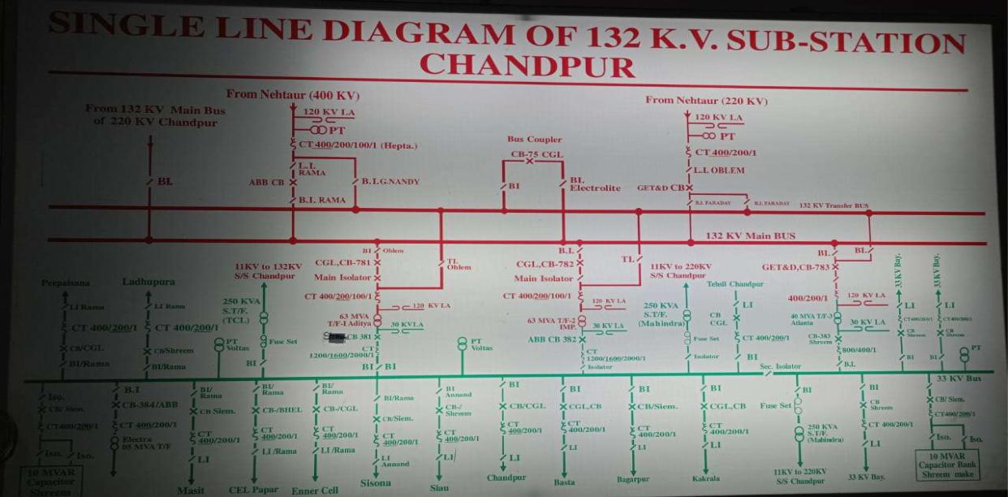

### Figure 1.2 Single line Diagram

## TRANSFORMERS

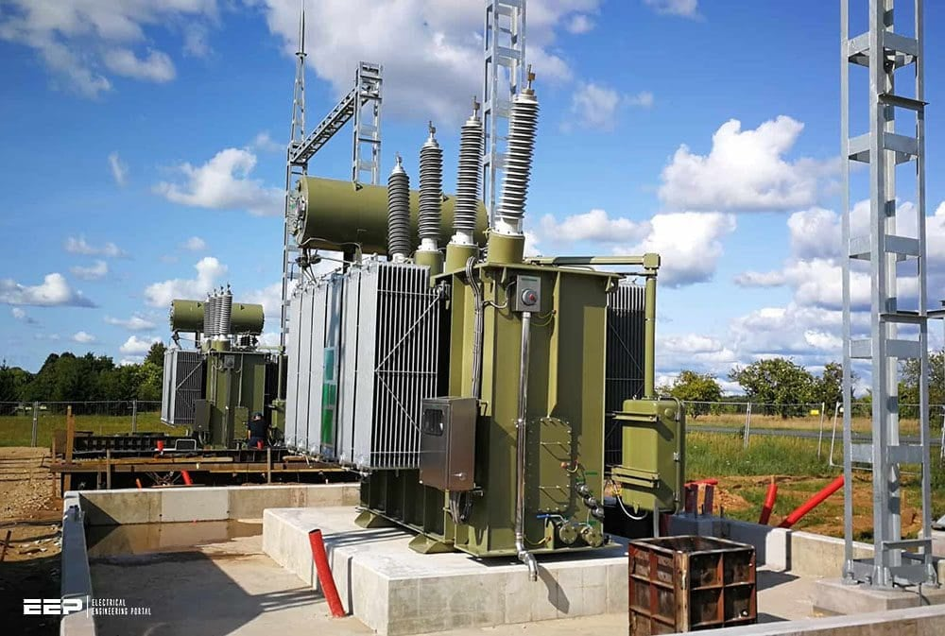**Figure: 2.1 Transformer**

Transformer is a static machine, which transforms the potential of alternating current at same frequency. It means the transformer transforms the low voltage into high voltage & high voltage to low voltage at same frequency. It works on the principle of static induction principle. When the energy is transformed into a higher voltage, the transformer is called step up transformer but in case of other is known as step down transformer.

### 2.1 TYPES OF TRANSFORMER

2.1.1 Power transformer

2.1.2 Instrument transformer

2.1.3 Auto transformer

2.1.4 On the basis of working

2.1.5 On the basis of structure

**2.1.1 POWER TRANSFORMER:**

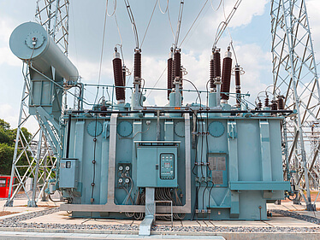

**Figure 2.2 Power Transformers**

Types of power transformer:

2.1.1.1 Single phase transformer

2.1.1.2 Three phase transformer

**2.1.2 INSTRUMENT TRANSFORMER:**

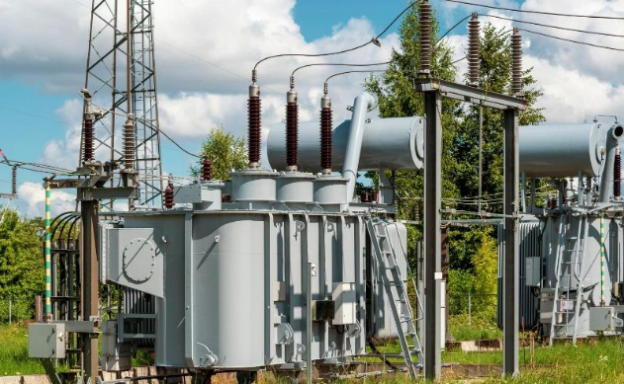

**Figure: 2.3 Instrument Transformers**

1. Current transformer
2. Potential transformer

**2.1.3 AUTO TRANSFORMER:**

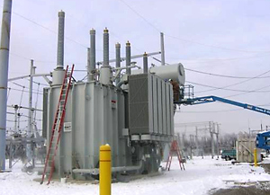

#### Figure 2.4 Auto Transformer

1. Single phase transformer
2. Three phase transformer

**2.1.4 ON THE BASIS OF WORKING**

**2.1.4.1** **Step down**: Converts high voltage into low voltage.

**2.1.4.2 Step up**: Converts low voltage into high voltage.

**2.1.5 ON THE BASIS OF STRUCTURE**

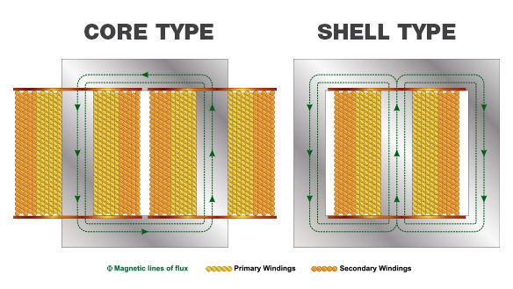

**Figure 2.5 core type Figure 2.6 Shell type**

**3. SPECIFICATION OF C.T. USED IN 33/11 KV SUB STATION, GIDAHI**

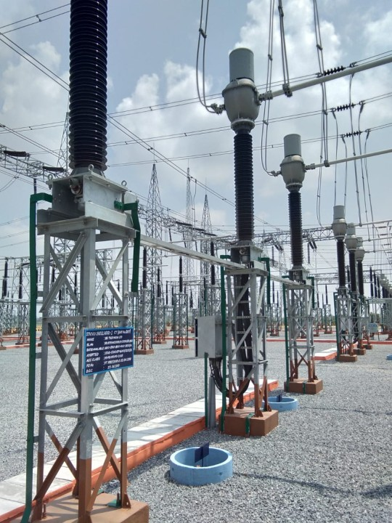

#### Figure 3.1 Current transformer

#### 

3.1 Standard: IS-27853.2 Highest System Voltage: 145 KV3.3 Frequency: 50Hz3.4 C.T. Current: 25 KA/1Sec.3.5 Rated primary current: 800 Ampere

## 4. SUBSTATIONS

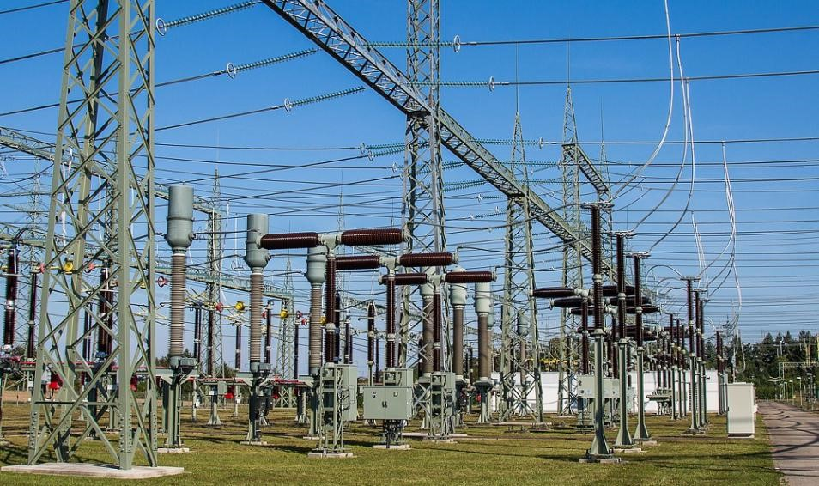**Figure 4.1 View of substation**

The present day electrical power system is A.C .i.e. electrical power is generated, transmitted & distributed in the form of the alternating current. The electric power is produced at power plant stations which are located at favourable places generally quite away from the consumers. It is delivered to the consumers through a large network of transmission 7 distribution.

At many places in the power system, it may be desirable and necessary to change some characteristics e.g. voltage, ac to dc, frequency, power factor etc. of electric supply. This accomplished by suitable apparatus called substation. For example; generation voltage (11 KV or 33 KV) at the power station is set up to high voltage (say 220 KV or 132 KV) for transmission of electric power. The assembly of apparatus (e.g. transformer etc.) used for this purpose in the substation. Similarly near the consumer’s localities, the voltage may have to be step down to utilization level. This job is again accomplished by suitable apparatus called substation.

The assembly of apparatus to change some characteristic of electric power supply is called substation.

The two most ways to classify substation are:-

### 4.1 TYPES OF SUBSTATION

**4.1.1 According to the service requirement:**

4.1.1.1 Transformer substation

4.1.1.2 Switch substation

4.1.1.3 Power factor correction substation

4.1.1.4 Frequency change substation

4.1.1.5 Converting substation

4.1.1.6 Industrial substation

**4.1.2 According to the constructional features:**

4.1.2.1 Indoor substation

4.1.2.3 Outdoor substation

4.1.2.4 Underground substation

4.1.2.5 Pole mounted substation

4.1.1.1 TRANSFORMER SUBSTATION

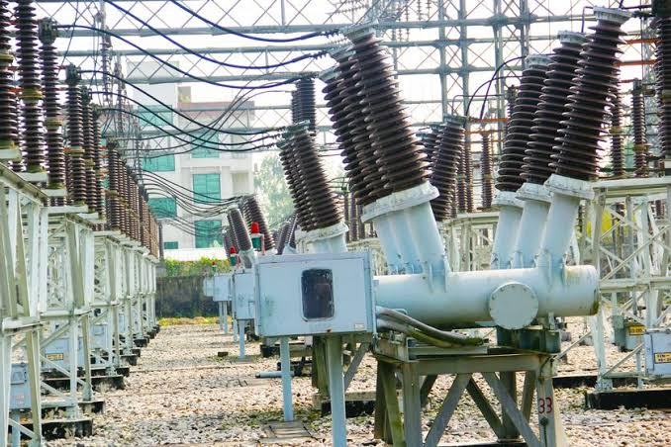

**Figure 4.2 Transformer substation**

They are known as transformer substations as because transformer is the main component employed to change the voltage level, depending upon the purposed served transformer substations may be classified into:

##### 4.1.1.1.1 STEP UP SUBSTATION

The generation voltage is steeped up to high voltage to affect economy in transmission of electric power. These are generally located in the power houses and are of outdoor type.

##### 4.1.1.1.2 PRIMARY GRID SUBSTATION

Here, electric power is received by primary substation which reduces the voltage level to 11KV for secondary transmission. The primary grid substation is generally of outdoor type.

##### 4.1.1.1.3 SECONDARY SUBSTATIONS

At a secondary substation, the voltage is further steeped down to 11KV. The 11KV lines runs along the important road of the city. The secondary substations are also of outdoor type.

##### 4.1.1.1.3 DISTRIBUTION SUBSTATION

These substations are located near the consumer’s localities and step down to 400V, 3-phase, 4-wire for supplying to the consumers. The voltage between any two phases is 400V & between any phase and neutral it is 230V.

**4.2 SUBSTATION CHARACTERISTICS:**

4.2.1 Each circuit is protected by its own circuit breaker and hence plant outage does not necessarily result in loss of supply.

4.2.2 A fault on the feeder or transformer circuit breaker causes loss of the transformer and feeder circuit, one of which may be restored after isolating the faulty circuit breaker.

4.2.3 A fault on the bus section circuit breaker causes complete shutdown of the substation. All circuits may be restored after isolating the faulty circuit breaker.

**4.3 STEPS IN DESIGNING SUBSTATION:**

The First Step in designing a Substation is to design an Earthing and Bonding System**.** **4.3.1 Earthing and Bonding:**

The function of an earthing and bonding system is to provide an earthing system connection to which transformer neutrals or earthing impedances may be connected in order to pass the maximum fault current. The earthing system also ensures that no thermal or mechanical damage occurs on the equipment within the substation, thereby resulting in safety to operation and maintenance personnel. The earthing system also guarantees equipotent bonding such that there are no dangerous potential gradients developed in the substation.

In designing the substation, three voltages have to be considered these are:

**4.3.1.1** Touch **Voltage**: This is the difference in potential between the surface potential and the potential at earthed equipment whilst a man is standing and touching the earthed structure.

**4.3.1.2** Step **Voltage**: This is the potential difference developed when a man bridges a distance of 1m with his feet while not touching any other earthed equipment.

**4.3.1.3 Mesh Voltage**: This is the maximum touch voltage that is developed in the mesh of the earthing grid.

**4.3.2 Substation Earthing Calculation Methodology**

Calculations for earth impedances, touch and step potentials are based on site measurements of ground resistivity and system fault levels. A grid layout with particular conductors is then analysed to determine the effective substation earthing resistance, from which the earthing voltage is calculated.

In practice, it is normal to take the highest fault level for substation earth grid calculation purposes. Additionally, it is necessary to ensure a sufficient margin such that expansion of the system is catered for.

To determine the earth resistivity, probe tests are carried out on the site. These tests are best performed in dry weather such that conservative resistivity readings are obtained.

**4.3.3 Earthing Materials**

**4.3.3.4 Conductors**:

Bare copper conductor is usually used for the substation earthing grid. The copper bars themselves usually have a cross-sectional area of 95 square millimetres, and they are laid at a shallow depth of 0.25-0.5m, in 3-7m squares. In addition to the buried potential earth grid, a separate above ground earthing ring is usually provided, to which all metallic substation plant is bonded.

**4.3.3.4 Connections:**

Connections to the grid and other earthing joints should not be soldered because the heat generated during fault conditions could cause a soldered joint to fail. Joints are usually bolted.

**4.3.3.5 Earthing Rods**:

The earthing grid must be supplemented by earthing rods to assist in the dissipation of earth fault currents and further reduce the overall substation earthing resistance. These rods are usually made of solid copper, or copper clad steel.

**4.3.4 Switchyard Fence Earthing**:

The switchyard fence earthing practices are possible and are used by different utilities.

**4.4 CONDUCTORS USED IN SUBSTATION DESIGN:**

An ideal conductor should fulfil the following requirements:

4.4.1 Should be capable of carrying the specified load currents and short time currents.

4.4.2 Should be able to withstand forces on it due to its situation. These forces comprise self-weight, and weight of other conductors and equipment, short circuit forces and atmospheric forces such as wind and ice loading.

4.4.3 Should be corona free at rated voltage.

4.4.4 Should have the minimum number of joints.

4.4.5 Should need the minimum number of supporting insulators.

4.4.6 Should be economical.

The most suitable material for the conductor system is copper or aluminium’s. Steel may be used but has limitations of poor conductivity and high susceptibility to corrosion.

In an effort to make the conductor ideal, three different types have been utilized, and these include: Flat surfaced Conductors, Stranded Conductors, and Tubular Conductors

**4.5 Overhead Line Terminations**

Two methods are used to terminate overhead lines at a substation. 4.5.1 Tensioning conductors to substation structures or buildings 4.5.2 Tensioning conductors to ground winches.

1. **CHRONOLOGICAL TRAINING DIARY**

**(based on study & observation at different Departments and sections)**

**5.1 POWER LINE CARRIER COMMUNICATION**

**Introduction:**

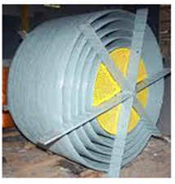

**Figure 5.1: PLCC (POWER LINE CARRIER COMMUNICATION)**

Reliable & fast communication is necessary for safe efficient & economical power

supply. To reduce the power failure in extent & time, to maintain the

interconnected grid system in optimum working condition; to coordinate the

operation of various generating unit communication network is indispensable for

state electricity board.

In state electricity boards, the generating & distribution stations are generally

located at a far distance from cities. Where P & T communication provided

through long overhead lines in neither reliable nor quick.

As we have available very reliable physical paths viz. the power lines, which

interconnected, hence power line carrier communication is found to be most

economical and reliable for electricity boards.

**5.1.1 APPLICATIONS:**

The PLCC can be used for the following facilities:

**5.1.1.1** Telephony

**5.1.1.2** Tele protection

**5.1.1.3** Remote control or indication

**5.1.1.4** Telemetry

**5.1.1.5** Teleprinting

**5.2 PRINCIPLE OF PLCC:**

The principle of PLCC is the simple one:

All type of information is modulated on carried wave at frequency 50Hz to 500 KHz. The modulated HF carrier fed into the power line conductor at the sending end and filtered out again at the respective stations. Long earlier system double side band amplitude modulation was more common but the present amplitude modulated system.

Since high voltage power lines are designed to carry large quantities of energy on the high voltage and the communication system at low voltage, they cannot be directly connected to high voltage lines. Suitably designed coupling equipment’s have therefore to be employed which will permit the injection of high frequency carrier signal without undue loss and with absolute protection of communication equipment’s or operating personal from high voltage hazard.

Therefore, the coupling equipment essentially comprises the following:

**5.2.1 Wave trap or line trap:**

Wave trap is connected in series with power line between the point of connection of coupling capacitor and S/S. Wave trap offers negligible impedance to HF carrier. Wave trap stands electromechanically and thermally for short circuit current in the event of fault on the line. On the basis of blocking frequency bank, the wave trap can be following type:

##### 5.2.1.1 ALL WAVE

##### 5.2.1.2 SINGAL FREQUENCY

##### 5.2.1.3 DOUBLE FREQUENCY

##### 5.2.1.4 BROAD BAND

**5.2.2 Coupling capacitor:**

The modulated carrier is let into power line through coupling capacitor specially designed to with stand line voltage under all-weather condition. The upper end of the coupling capacitor is connected directly to the line and the lower end is connected to the ground through a carrier frequency chock coil or drain coil. Thus coupling capacitor forms the link between the PLCC equipment and power line. The coupling capacitor used in UPSEB is 2200pf capacitance.

The coupling capacitor are designed for outdoor use and hence to withstand normal atmospheric phenomenon such as temperature & humidity changes, rain, snow, anticipated wind load, nominal wire tension etc. at full rated voltage. In some case capacitive voltage transformers (CVT) used as a source of line voltage for metering and protection as also used coupling capacitor for PLCC.

**5.2.3 Protective Device of Coarse Voltage Arrester:**

This is connected across the primary of the coupling filter i.e. one end is connected to the bottom of the coupling capacitor and other end is earthed. This is provided to protect the coupling filter against line surges. An air gap is provided, where voltage of the order of 1.8 to 2KV as observed across due to lighting etc. on line.

**5.2.4 Coupling of Filter:**

The coupling filter is inserted between the low voltage terminal of the coupling capacitor and the carrier frequency connection of the carrier terminal. Sometime an earth switch is also provided with this unit. This unit mainly performs two functions; firstly it isolates the connection of equipment from the power line. Secondly it serves to match characteristic impedance of the power line to that of the H.F. cable to connection equipment’s.

**5.2.5 H.F. Cable:**

H.F. cable normally used to connect the coupling filter to another coupling terminal. The cable is insulated to withstand the test voltage of 4KV. The impedance of this H.F. cable is so as to match with the output of the PLCC terminal and secondary impedance of coupling filter.

**5.2.5.1 TYPES OF COUPLING:**

The following three types of coupling are being used in UPSEB depending on the requirement:

5.2.5.1.1 Phase to ground coupling

5.2.5.1.2 Phase to phase coupling

5.2.5.1.3 Internal coupling

**5.2.5.2 COUPLING LOSSES:**

5.2.5.2.1 Composite loss

5.2.5.2.2 Tapping loss

5.2.5.2.3 H.F. cable loss

5.2.5.2.4 Additional loses

1. **BUSBARS**

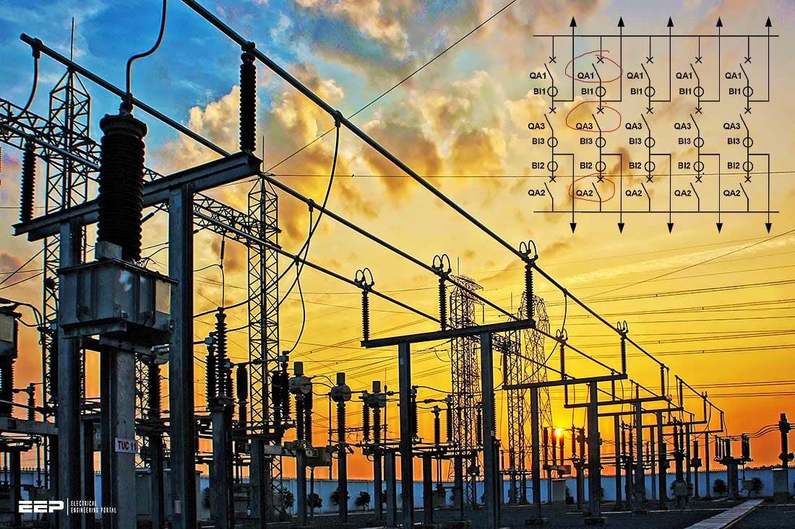

#### Figure 6.1 bus bars

When numbers of generators or feeders operating at the same voltage have to be directly connected electrically, bus bar is used as the common electrical component. Bus bars are made up of copper rods operate at constant voltage. The following are the important bus bars arrangements used at substations:

6.1 Single bus bar system

6.2 Single bus bar system with section alisation.

6.3 Duplicate bus bar system

In large stations it is important that break downs and maintenance should interfere as little as possible with continuity of supply to achieve this, duplicate bus bar system is used. Such a system consists of two bus bars, a main bus bar and a spare bus bar with the help of bus coupler, which consist of the circuit breaker and isolator.

In substations, it is often desired to disconnect a part of the system for general maintenance and repairs. An isolating switch or isolator accomplishes this. Isolator operates under no load condition. It does not have any specified current breaking capacity or current making capacity. In some cases isolators are used to breaking charging currents or transmission lines.

While opening a circuit, the circuit breaker is opened first then isolator while closing a circuit the isolator is closed first, then circuit breakers. Isolators are necessary on supply side of circuit breakers, in order to ensure isolation of the circuit breaker from live parts for the purpose of maintenance.

A transfer isolator is used to transfer main supply from main bus to transfer bus by using bus coupler (combination of a circuit breaker with two isolators), if repairing or maintenance of any section is required.

### 7. INSULATORS

The insulator serves two purposes. They support the conductors (bus bar) and confine the current to the conductors. The most common used material for the manufacture of insulator is porcelain. There are several types of insulators (e.g. pin type, suspension type, post insulator etc.) and their use in substation will depend upon the service requirement. For example, post insulator is used for bus bars. A post insulator consists of a porcelain body, cast iron cap and flanged cast iron base. The hole in the cap is threaded so that bus bars can be directly bolted to the cap.

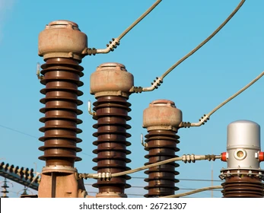**Figure 7.1 Insulators used in substations**

With the advantage of power system, the lines and other equipment operate at very high voltage and carry high current.

The arrangements of switching along with switches cannot serve the desired function of switchgear in such high capacity circuits. This necessitates employing a more dependable means of control such as is obtain by the use of the circuit breakers. A circuit breaker can make or break a circuit either manually or automatically under all condition as no load, full load and short circuit condition.

A circuit breaker essentially consists of fixed and moving contacts. These contacts can be opened manually or by remote control whenever desired. When a fault occurs on any part of the system, the trip coils of breaker get energized and the moving contacts are pulled apart by some mechanism, thus opening the circuit.

When contacts of a circuit breaker are separated, an arc is struck; the current is thus able to continue. The production of arcs are not only delays the current interruption, but is also generates the heat. Therefore, the main problem is to distinguish the arc within the shortest possible time so that it may not reach a dangerous value.

The general way of classification is on the basis of the medium used for arc extinction.

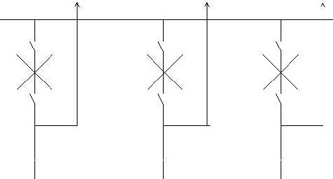

#### Figure 7.2 Circuit breaker arrangements

**7.1. Circuit breakers**

They can be classified into:

7.1.1 Oil circuit breaker 7.1.2 Air-blast circuit breaker 7.1.3 Sulphur hexafluoride circuit breaker (SF6) 7.1.4 Vacuum circuit breakers

**Note:** SF6 and Vacuum circuit breaker are being used in 33KV distribution substation.

#### 7.2 Oil Circuit Breaker

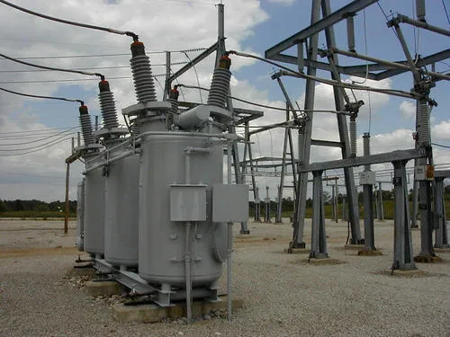

**Figure 7.3 Oil circuit breaker**

A high-voltage circuit breaker in which the arc is drawn in oil to dissipate the heat and extinguish the arc; the intense heat of the arc decomposes the oil, generating a gas whose high pressure produces a flow of fresh fluid through the arc that furnishes the necessary insulation to prevent a restrike of the arc.

The arc is then extinguished, both because of its elongation upon parting of contacts and because of intensive cooling by the gases and oil vapor.

#### 7.3 Air blast circuit breaker

Fast operations, suitability for repeated operation, auto reclosure, unit type multi break constructions, simple assembly, modest maintenance are some of the main features of air blast circuit breakers. A compressors plant necessary to maintain high air pressure in the air receiver. The air blast circuit breakers are especially suitable for railways and arc furnaces, where the breaker operates repeatedly. Air blast circuit breakers is used for interconnected lines and important lines where rapid operation is desired. High pressure air at a pressure between 20 to 30 kg/ cm2 stored in the air reservoir. Air is taken from the compressed air system. Three hollow insulator columns are mounted on the reservoir with valves at their basis. The double arc extinguished chambers are mounted on the top of the hollow insulator chambers.

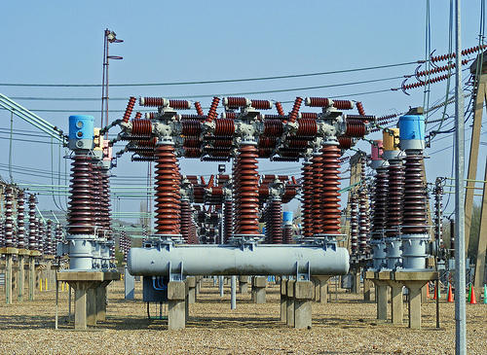

##### Figure 7.4 Air blast circuit breaker

The current carrying parts connect the three arc extinction chambers to each other in series and the pole to the neighbouring equipment. Since there exists a very high voltage between the conductor and the air reservoir, the entire arc extinction chambers assembly is mounted on insulators.

**7.4 SF6  CIRCUIT BREAKER:**

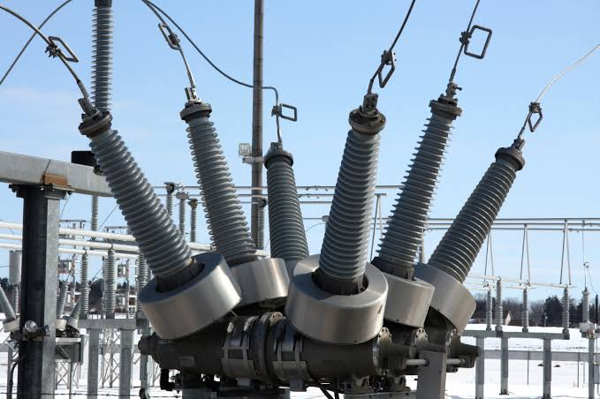

##### Figure 7.5 SF6 Circuit breaker

In such circuit breaker, sulphur hexafluoride (SF6) gas is used as the arc quenching medium. The SF6 is an electronegative gas and has a strong tendency to absorb free electrons. The SF6 circuit breaker have been found to a very effective for high power and high voltage service. SF6 circuit breakers have been developed for voltage 115 KV to 230 KV, power rating 10 MVA.

It consists of fixed and moving contacts. It has chamber, contains SF6 gas. When the contacts are opened, the mechanism permits a high pressure SF6 gas from reservoir to flow towards the arc interruption chamber. The moving contact permits the SF6 gas to let through these holes.

#### 7.5 Vacuum Circuit Breaker

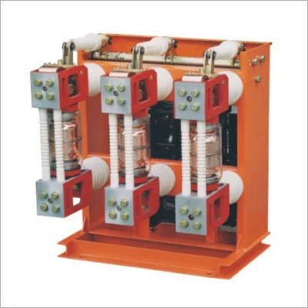

##### Figure 7.6 Vacuum circuit breaker

Vacuum circuit breakers are circuit breakers which are used to protect medium and high voltage circuits from dangerous electrical situations. Like other types of circuit breakers, vacuum circuit breakers literally break the circuit so that energy cannot continue flowing through it, thereby preventing fires, power surges, and other problems which may emerge. These devices have been utilized since the 1920s, and several companies have introduced refinements to make them even safer and more effective.

**7.2.1 Rating of 132 KV SF6 circuit breaker:**

7.2.1.1 Breaking current: 50A

7.2.1.2 Making capacity: 80KA

7.2.1.3 Total break time < 60msec

7.2.1.4 Rated short circuit breaking current:

7.2.1.4.1 Symmetrical: 31.5 KA

7.2.1.4.2 Asymmetrical: 36.86 KA

7.2.1.5 Rated duration of short circuit current: 3sec

7.2.1.6 Rated nominal current: 1250 A

7.2.1.7 Rated voltage: 145 KV

7.2.1.8 Rated SF6 gas pressure: 6 KG

1. **METERING AND INDICATION EQUIPMENT** 
   1. **RELAY:**

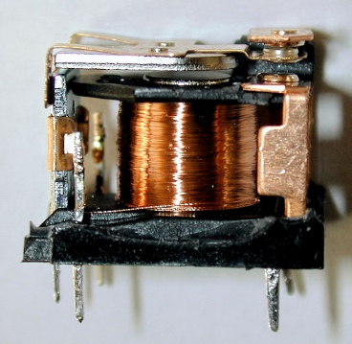

**Figure 8.1 Typical view of Relay**

In a power system it is inevitable that immediately or later some failure does occur somewhere in the system. When a failure occurs on any part of the system, it must be quickly detected and disconnected from the system. Rapid disconnection of faulted apparatus limits the amount of damage to it and prevents the effects of fault from spreading into the system. For high voltage circuits relays are employed to serve the desired function of automatic protective gear. The relays detect the fault and supply the information to the circuit breaker.

The electrical quantities which may change under fault condition are voltage, frequency, current, phase angle. When a short circuit occurs at any point on the transmission line the current flowing in the line increases to the enormous value. This result in a heavy current flow through the relay coil, causing the relay to operate by closing its contacts. This in turn closes the trip circuit of the breaker making the circuit breaker open and isolating the faulty section from the rest of the system. In this way, the relay ensures the safety of the circuit equipment from the damage and normal working of the healthy portion of the system. Basically relay work on the following two main operating principles:

**8.1.1 Electromagnetic attraction relay**

**8.1.2 Electromagnetic induction relay**

#### 8.2 Relays used in control panel of the substation:

**8.2.1 Differential Relay:**

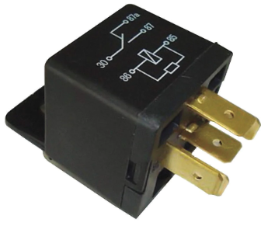

**Figure 8.2 Differential Relay**

A differential relay is one that operates when vector difference of the two or more electrical quantities exceeds a predetermined value. If this differential quantity is equal or greater than the pickup value, the relay will operate and open the circuit breaker to isolate the faulty section.

**8.2.2 OVER CURRENT RELAY:**

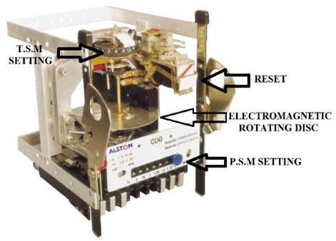

**Figure 8.3 Overcurrent Relay**

This type of relay works when current in the circuit exceeds the predetermined value. The actuating source is the current in the circuit supplied to the relay from a current transformer. These relay are used on A.C. circuit only and can operate for fault flow in the either direction.

This relay operates when phase to phase fault occurs.

**8.2.3 DIRECTIONAL RELAY:**

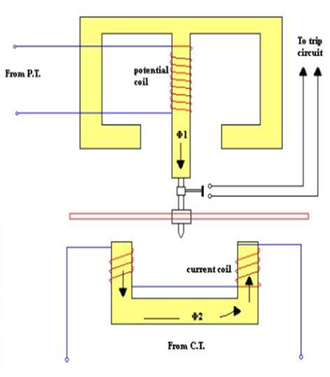

**Figure 8.4 Directional Relay**

This relay operates during earth faults. If one phase touches the earth due to any fault. A **directional power relay** is so designed that it obtains its operating torque by the interaction of magnetic field derived from both voltage and current source of the circuit it protects. The direction of torque depends upon the current relative to voltage.

**8.2.4 TRIPPING RELAY:**

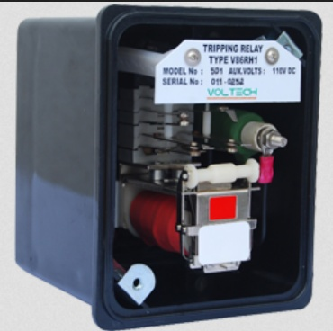

**Figure 8.5 Tripping Relay**

This type of relay is in the conjunction with main relay. When main relay sense any fault in the system, it immediately operates the trip relay to disconnect the faulty section from the section .

**8.2.5 AUXILIARY RELAY:**

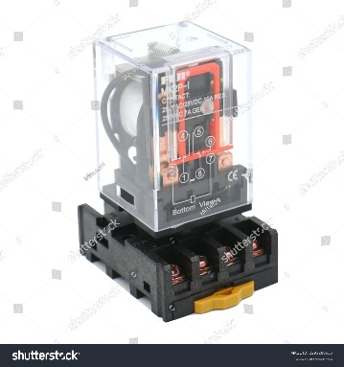

**Figure 8.6 Auxiliary Relay**

An auxiliary relay is used to indicate the fault by glowing bulb alert the employee.

### 9. MISCELLANOUS EQUIPMENT

**9.1 CAPACITOR BANK:**

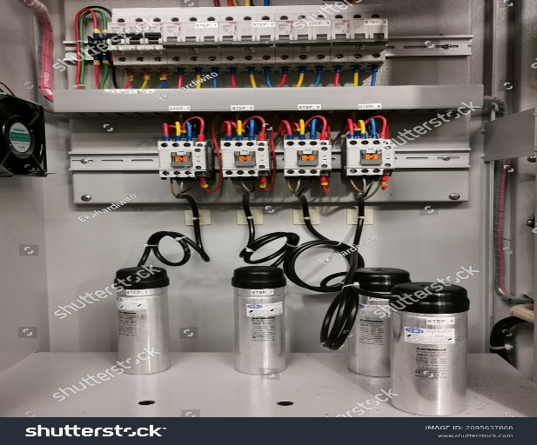

**Figure 9.1 Capacitor bank**

The load on the power system is varying being high during morning and evening which increases the magnetization current. This result in the decreased power factor. The low power factor is mainly due to the fact most of the power loads are inductive and therefore take lagging currents. The low power factor is highly undesirable as it causes increases in current, resulting in additional losses. So, in order to ensure most favourable conditions for a supply system from engineering and economical stand point it is important to have power factor as close to unity as possible. In order to improve the power factor come device taking leading power should be connected in parallel with the load. One of the such device can be **capacitor bank**. The capacitor draws a leading current and partly or completely neutralize the lagging reactive component of load current.

**Capacitor bank accomplishes following operations:**

9.1.1 Supply reactive power

9.1.2 Increases terminal voltage

9.1.3 Improve power factor

**9.2 FUSE:**

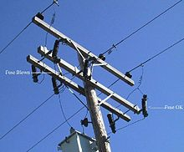

**Figure 9.2 Substation Fuse**

A fuse is a short piece of wire or thin strip which melts when excessive current through it for sufficient time. It is inserted in series with the circuit under normal operating conditions; the fuse element is at a nature below its melting point. Therefore it carries the normal load current overheating. It is worthwhile to note that a fuse performs both detection and interruption functions.

**9.3 BUS COUPLER:**

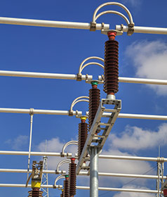

#### Figure 9.3 bus coupler

The bus coupler consists of circuit breaker and isolator. Each generator and feeder may be connected to either main bus bar or spar bus bar with the help of bus coupler.

**10. LIGHTINING ARRESTER**

The device which is used for the protection of the equipment at the substations against travelling waves, such type of device is called lightning arrester or surge diverter. In other words, lightning arrester diverts the abnormal high voltage to the ground without affecting the continuity of supply. It is connected between the line and earth, i.e., in parallel with the equipment to be protected at the substation.

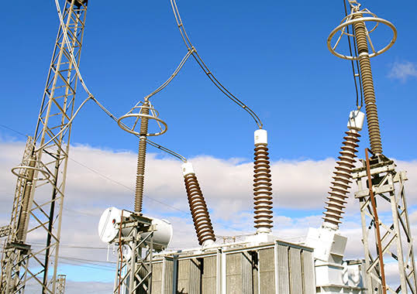

**Figure 10.1 Lightening Arrester**

**11. PROTECTION OF SUBSTATION**

**11.1 Transformer protection:**

Transformers are totally enclosed static devices and generally oil immersed. Therefore chances of fault occurring on them are very easy rare, however the consequences of even a rare fault may be very serious unless the transformer is quickly disconnected from the system. This provides adequate automatic protection for transformers against possible faults.

**11.2 Conservator and Breather:**

When the oil expands or contacts by the change in the temperature, the oil level goes either up or down in main tank. A conservator is used to maintain the oil level up to predetermined value in the transformer main tank by placing it above the level of the top of the tank.

Breather is connected to conservator tank for the purpose of extracting moisture as it spoils the insulating properties of the oil. During the contraction and expansion of oil air is drawn in or out through breather silica gel crystals impregnated with cobalt chloride. Silica gel is checked regularly and dried and replaced when necessary.

**11.3 Marshalling box:**

It has two meter which indicate the temperature of the oil and winding of main tank. If temperature of oil or winding exceeds than specified value, relay operates to sound an alarm. If there is further increase in temperature then relay completes the trip circuit to open the circuit breaker controlling the transformer.

**11.4 Transformer cooling:**

When the transformer is in operation heat is generated due to iron losses the removal of heat is called cooling.

### CONCLUSION

Now from this report we can conclude that electricity plays an important role in our life. We are made aware of how the transmission of electricity is done. We too came to know about the various parts of the Substation system.

The Purvanchal Vidyut Vitaran Nigam Limited has got radio communication in microwave range in order to transmit and receive data with various Substations in Uttar Pradesh to get reliable transmission and distribution of electricity.

**References**

1. [www.mvvnl.in/en](http://www.mvvnl.in/en)
2. [www.scribd.com/document/686636980/Industrial-Training-Report-Sample](http://www.scribd.com/document/686636980/Industrial-Training-Report-Sample)
3. [www.slideshare.net](http://www.slideshare.net)

1. [www.google.co.in/imghp](http://www.google.co.in/imghp)
2. <https://academicanswers.waldenu.edu>
3. guides.library.uq.edu.au